**Chapter 3 Question 38 in textbook**

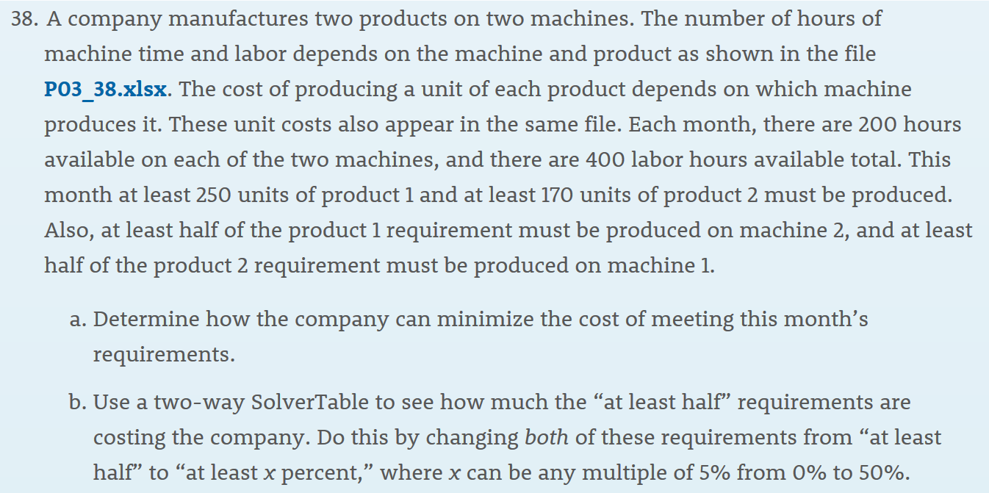

**Re-write problem:**

Every year, Black Friday is the most exciting festival and the best opportunity for shopping. After 2019 Black Friday, a company has to decide how to allocate two available shipping routes for two products. The number of days of shipping and labor hours depends on the routes and product as shown in the file. The cost of shipping one unit of each product depends on which route ships it. These unit costs also appear in the same file. In this month, there are 30 shipping days available on each of the two routes, and there are 400 labor hours available in total. This month at least 10 units of product 1 and at least 8 units of product 2 must be shipped. Also, at least half of product 1 requirement must be shipped via route 2, and at least half of the product 2 requirement must be shipped via route 1. The products are large machines, here we assume only one product can be shipped in each shipment and the next product can only be shipped when the previous shipment of the same route is finished. (eg: for route 1, one unit of product 1 is shipped on the first day, the second unit of route 1 can only be shipped on the fourth day since the shipping days of product 1 via route 1 is 3 days.)

Determine how the company can minimize the cost of meeting this month’s requirements.